|  |  |  |  |
| --- | --- | --- | --- |
| Class | Figure | Featured in | Characteristics |
| Operative |  | Borderlands 3 | Can cast hologram to draw attention and fire. Protect teammate. |
| Mechanician |  | Borderlands 2  Borderlands 3 | Can build (summon) turret (Mecha), infinite shield was one of the most powerful build. |
| Psycho |  | Borderlands 2  Borderlands 3 | Chainsaw, melee weapons, health recover on hostile elimination. |
| Siren |  | All Borderlands games | Can pull or push enemies, heal teammate. |
| Gunserker |  | Borderlands  Borderlands 2 | Master of heavy power and can hold more than one at a time |
| Assassin |  | Borderlands 2  Borderlands 3 | Flexible sneaky sniper |

dwa

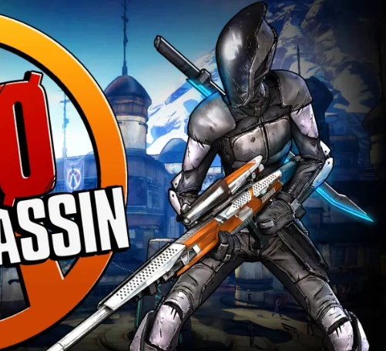

|  |  |  |
| --- | --- | --- |
|  |  |  |
| **Operative | Borderlands 3**  Can cast hologram to draw attention and fire. Protect teammate. | **Psycho | Borderlands 2, Borderlands 3**  Chainsaw, melee weapons, health recover on hostile elimination. | **Assassin | Borderlands 2, Borderlands 3**  Flexible sneaky sniper |
|  |  |  |
|  |  |  |
| **Mechanician | Borderlands 2, Borderlands 3 |**  Can build (summon) turret (Mecha), infinite shield was one of the most powerful build. | **Gunserker | Borderlands 2, Borderlands 3**  Master of heavy power and can hold more than one at a time. | **Siren | All Borderlands Games**  Can control, pull or push enemies, and heal teammates. |